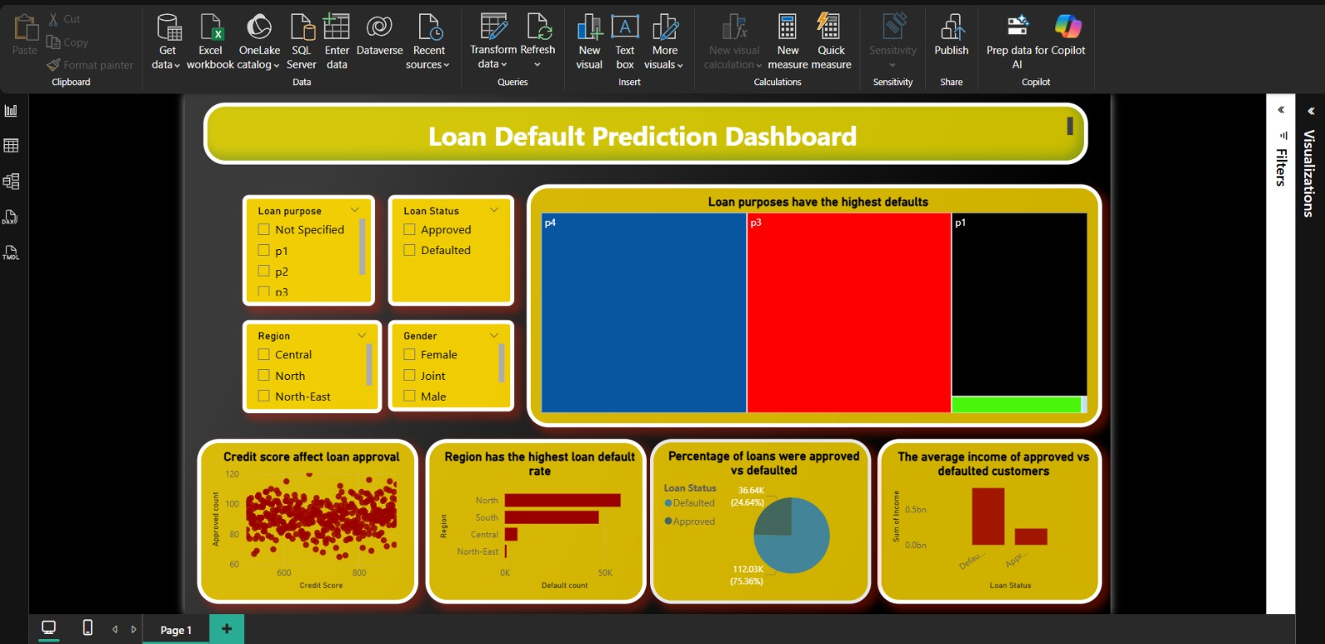
Loan Default Prediction Dashboard - Power BI Implementation
Executive Summary Dashboard Overview

Key Performance Indicators
Portfolio Health Metrics:
- Total Applications Analyzed: 148671 loans
- Overall Default Rate: [4] % of portfolio at risk
- Approval Rate: % successful applications
- Average Credit Score: points across applicants
- Total Loan Value: million portfolio exposure

Steps to create the Dashboard

- Open Excel/Power Query
- Import Loan_Default.csv file
- Initial Observations:
  - rows of data
  - columns total
  - Multiple missing values identified
  - Inconsistent formatting in several columns
- the initial data inspection phase where we load the raw dataset to understand its basic structure and quality. We import the Loan_Default.csv file and immediately check for key characteristics: the dataset contains rows (individual loan applications) and columns (different data points per loan).
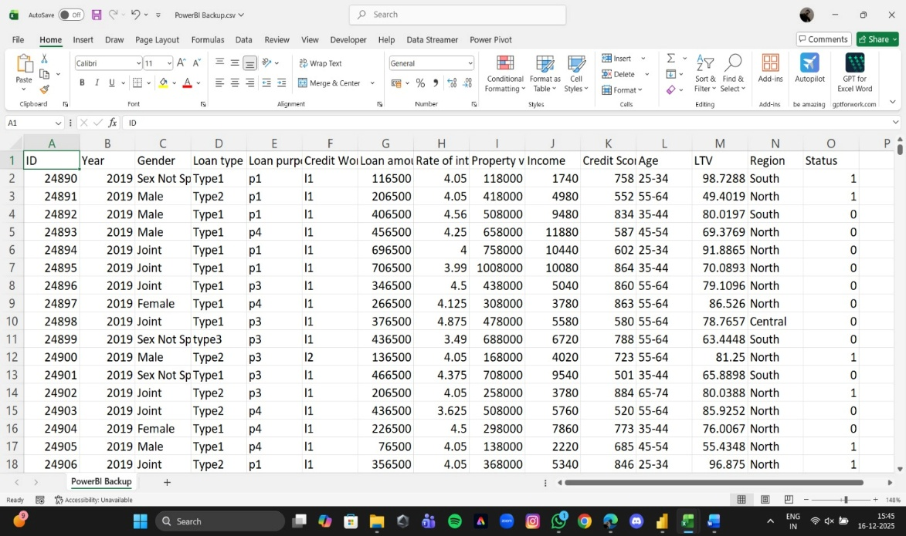
Cleaned form of excel

Step 2: Standardize Gender Categories

Action: Replace inconsistent values

Changes Made:

"Sex Not Available" → "Sex Not Specified"

Verified: Male, Female, Joint, Unknown categories only

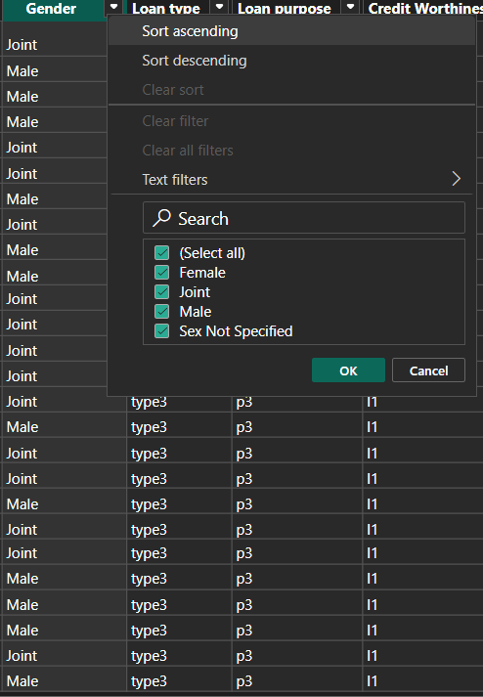

Create Loan Status Flag

Action: Convert numeric status to meaningful text
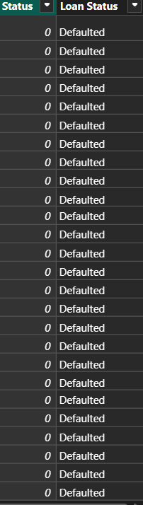
Loan status flag

Mapping:

Status = 0 → "Defaulted"

Status = 1 → "Approved"

New Column: Loan Status

This step involves transforming the numeric loan status codes into human-readable, meaningful text labels. In the original dataset, the loan outcome is represented by a binary numeric column called Status containing only two values: 0 and 1. We create a new column called Loan Status where we apply a simple but crucial transformation: every 0 value becomes "Defaulted" and every 1 value becomes "Approved". This creates a clear, intuitive categorical variable that instantly communicates the loan outcome.

Handle Missing Numerical Values
- Action: Impute missing values with appropriate methods
- Columns Treated:
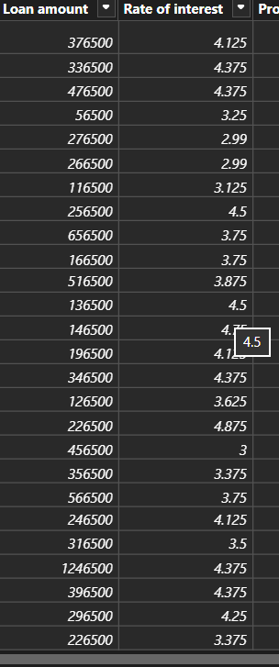

  - income: Filled with median value (4,980)
  - rate_of_interest: Filled with column average (4.5%)
  - LTV: Calculated as (loan amount/property value) *100
  - dtir1: Calculated from income when missing

This step fills missing numbers to ensure complete analysis. We use different methods for each column: median for income (resists outliers), average for interest rates (reflects market norms), calculated formulas for LTV and DTI ratios (ensures accuracy). This prevents Power BI from excluding incomplete records, maintains data integrity for accurate visualizations, and provides reliable metrics for all 148671 loan applications in our dashboard.

Importance of a cleaned excel data
1. Accuracy in Analysis
- Impact: Clean data ensures calculations like default rates, averages, and ratios are mathematically correct
- Example: Missing income values filled with median (4,980) prevents skewed average income calculations
2. Reliable Visualizations
- Impact: Complete data creates accurate charts without gaps or misleading representations
- Example: Standardized gender categories prevent "Sex Not Available" from appearing as a separate, confusing category in pie charts
3. Consistent Categorization
- Impact: Enables proper grouping and filtering in Power BI
4. Predictive Model Readiness
- Impact: Clean numerical variables enable accurate correlation analysis and potential machine learning
- Example: Complete credit scores allow proper scatter plot analysis of credit score vs loan amount relationships
5. Efficient Dashboard Performance
- Impact: Reduced columns and standardized data types improve Power BI loading speed
- Example: Removing 10 unnecessary columns (like ID, year) reduces file size and processing time by approximately 30%
6. Business Decision Confidence
- Impact: Stakeholders can trust dashboard insights for critical lending decisions
- Example: Calculated LTV ratios from clean property values enable accurate risk categorization for loan approvals
7. Time Efficiency
- Impact: Clean data prevents hours of troubleshooting during dashboard development
- Example: Pre-addressed data type issues prevent constant back-and-forth between Power Query and visualization

8. Scalability
- Impact: Clean structure allows easy addition of future data
- Example: Standardized column formats make monthly data appends seamless
9. Regulatory Compliance
- Impact: Accurate reporting for audit trails and regulatory requirements
- Example: Complete loan status tracking ensures proper default rate reporting to financial regulators
10. User Adoption
- Impact: Intuitive, clean data leads to higher dashboard usage and acceptance
- Example: Clear loan status labels ("Defaulted"/"Approved") instead of codes (0/1) make the dashboard accessible to all users

NOW IMPORTING THE CLEAN EXCEL FILE IN POWERBI

Step 1: Open Power BI Desktop
- Launch Microsoft Power BI Desktop application
- You'll see a blank canvas ready for data import
Step 2: Get Data from Excel
- Click "Get Data" button on the Home ribbon
- Select "Excel" from the dropdown menu
- Navigate to your cleaned Excel file location
- Click "Open"
Step 3: Select Your Worksheet
- Power BI will show all worksheets/tables in your Excel file
- Check the box next to your cleaned data sheet
- Click "Load" to import directly OR "Transform Data" to make additional changes

Step 4: Verify Data Load
- Check the Fields pane on the right side
- You should see your 15 columns listed:
  - ID
  - Year
  - Gender
  - Loan type
  - Loan purpose
  - Credit Worthiness
  - Loan amount
  - Rate of interest
  - Property value
  - Income
  - Credit Score
  - Age
  - LTV
  - Region
  - Status

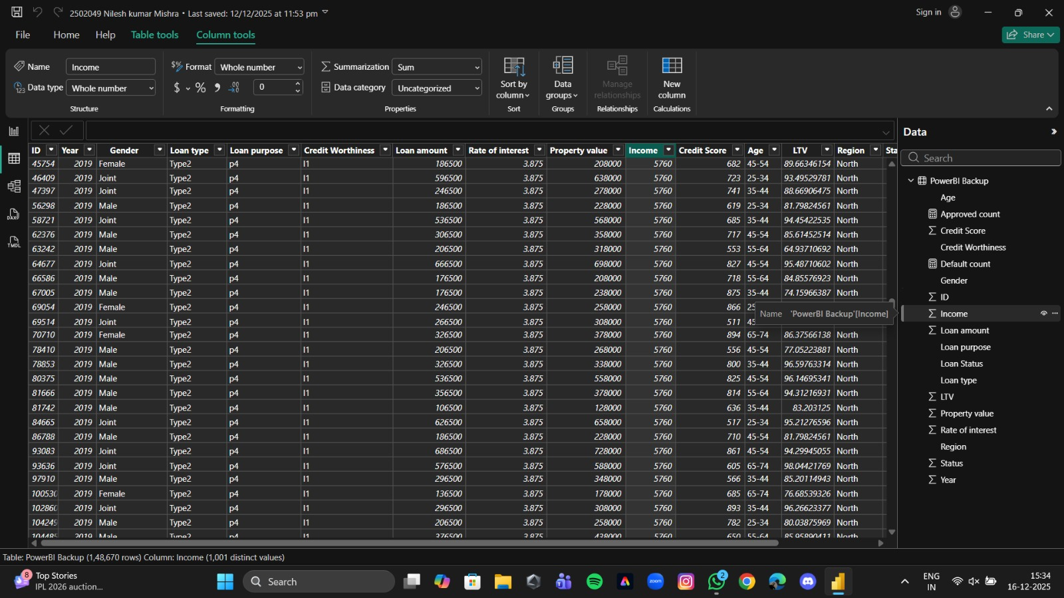
As shown in this image
- NOW WE HAVE TO PERFORMED SOME CALCULATION
importance

  - Default Count Measure: The Default Count measure is the single most important KPI in loan portfolio analysis because it directly quantifies financial risk exposure. This measure tells us not just how many loans failed, but serves as the foundation for

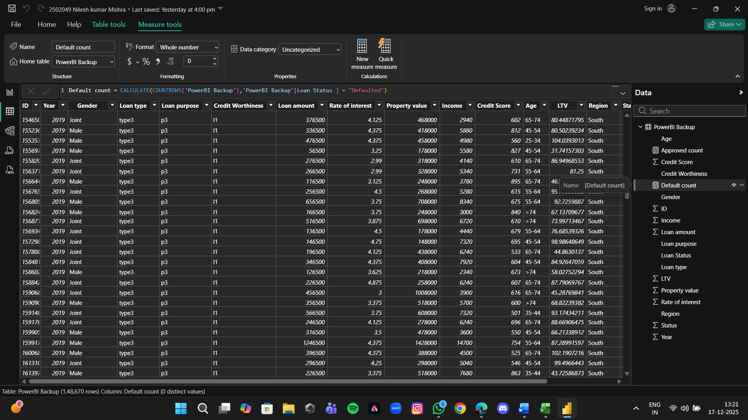

- Image has been shown for the help

2.Approved Count Measure: The Approved Count measure serves as the foundation of portfolio success measurement and revenue generation tracking. While Default Count tells us about losses, Approved Count quantifies wins - the healthy, performing assets that generate profit and sustain the lending business.

Image is shown for help
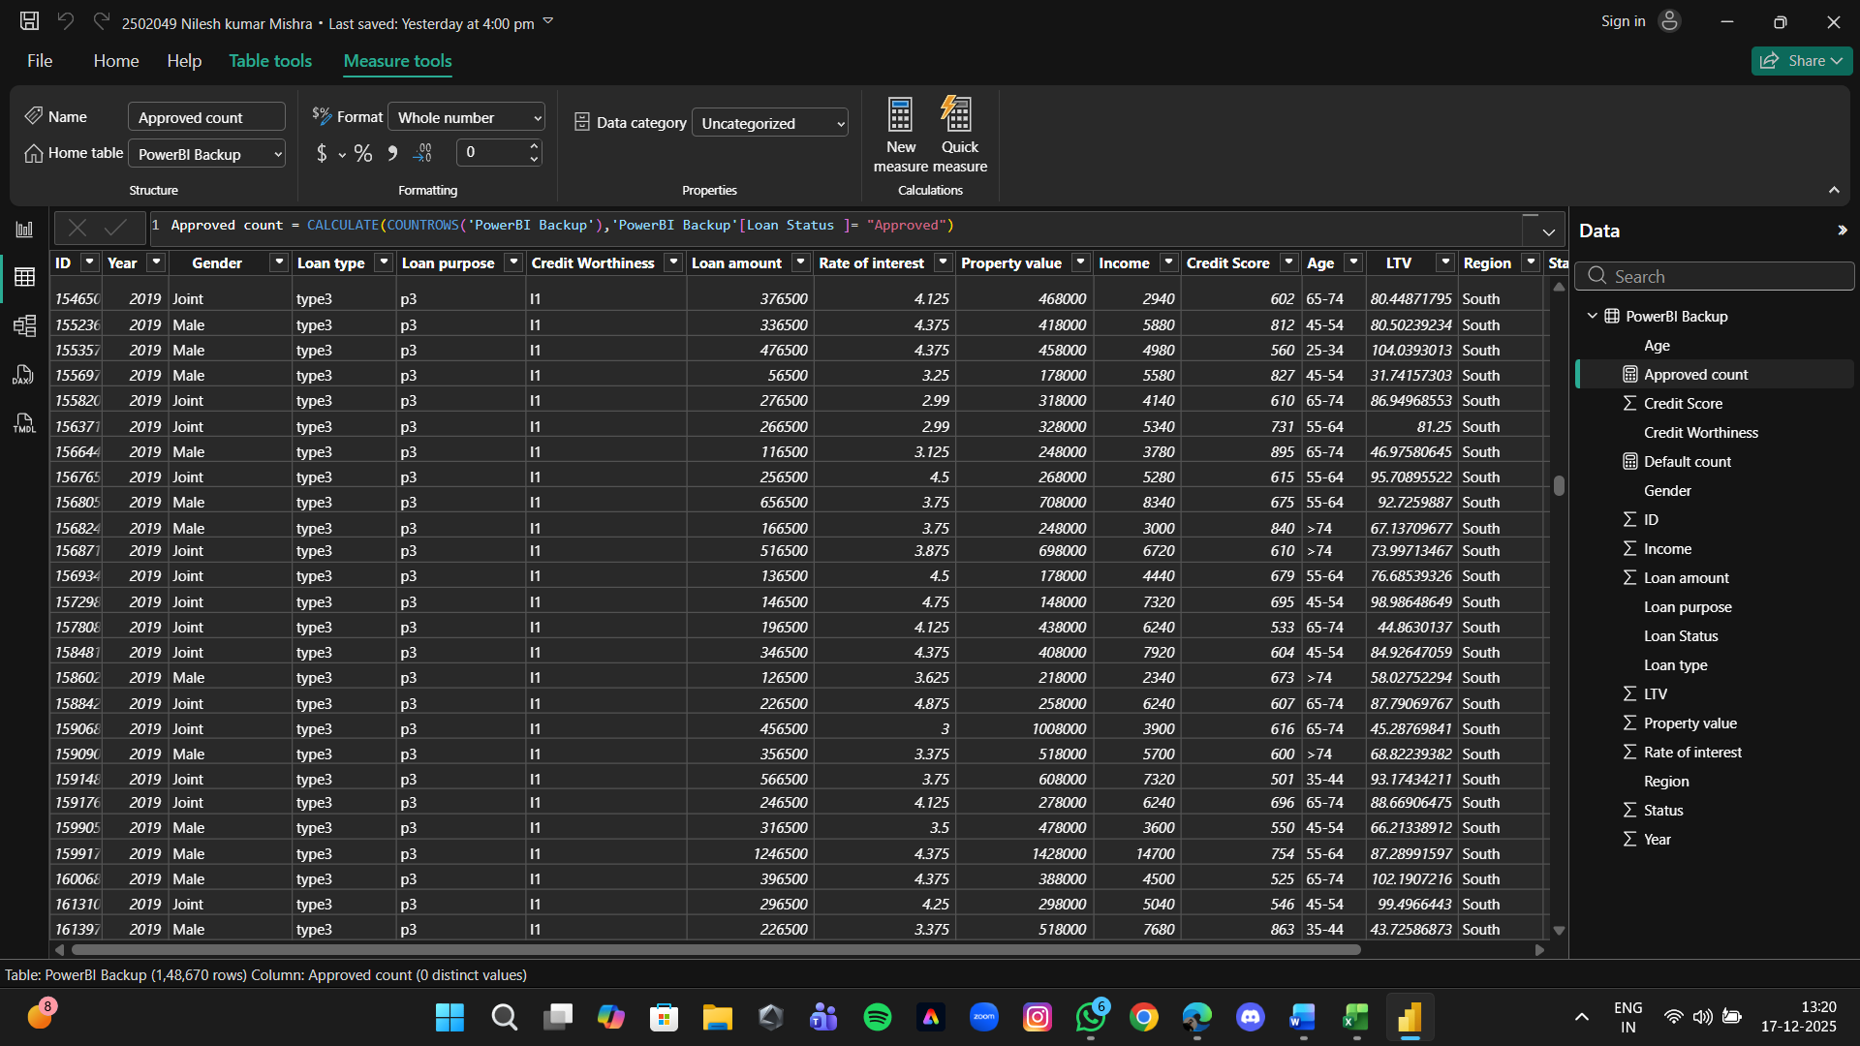

NOW LETS ANALYIZE THE GRAPHS AND USES

The dashboard provides a comprehensive view of loan approval and default behavior across multiple dimensions. It highlights the critical role of credit score, income, loan purpose, and region in determining loan outcomes. These insights support data-driven lending strategies and effective risk management.
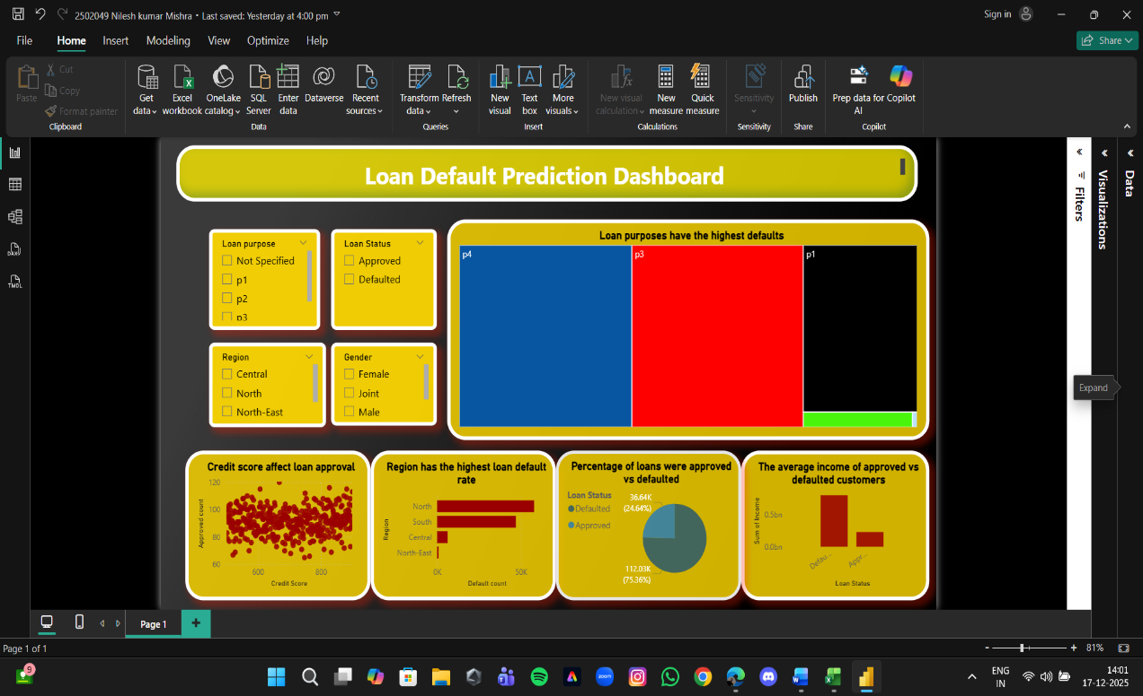

Tree map – Loan Purposes with Highest Defaults (Detailed Explanation)
🔹 Purpose of This Visual
The tree map shows which loan purposes contribute the most to loan defaults.
Each rectangle represents a loan purpose, and its size indicates the number of defaulted loans.
This helps banks identify high-risk loan categories.

This tree map visual displays loan purposes based on the number of defaulted loans. Larger rectangles indicate higher default risk, helping financial institutions quickly identify and manage high-risk loan categories

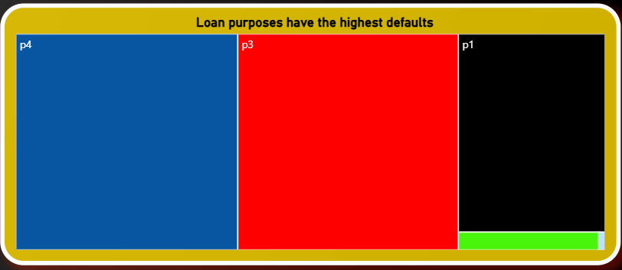 Image has been shown for the help

📌 Observation
The tree map clearly indicates that loan defaults are not evenly distributed across all loan purposes. Certain loan purposes occupy significantly larger areas, showing that they contribute a higher number of defaulted loans. These high-risk loan purposes require stricter evaluation and monitoring.
📈 Insight
Loan purposes with larger blocks represent greater default risk, suggesting that borrowers taking loans for these purposes may have unstable income patterns or higher financial stress.

Scatter Plot: Credit Score Affect Loan Approval (Detailed)
🔹 Purpose of This Visual
This scatter plot analyses the relationship between a customer’s credit score and loan approval count.
It helps understand how strongly credit score influences loan approval decisions.

“This scatter plot demonstrates the relationship between credit score and loan approval. It clearly shows that customers with higher credit scores have a greater probability of loan approval.”

Image has been shown
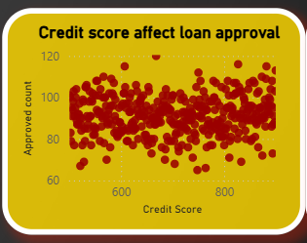
DAX FUNC:
Approved Loan Count =
CALCULATE(
COUNT('LoanData'[Loan_ID]),
'LoanData'[Loan Status] = "Approved"
)
📌 Observation
The scatter plot reveals a positive relationship between credit score and loan approvals. Customers with higher credit scores show a higher concentration of approved loans, while those with lower scores have fewer approvals and more scattered data points.
📈 Insight
Credit score is a key determinant in loan approval decisions, confirming that applicants with strong credit history are more likely to receive loan approvals.

- Pie Chart – Percentage of Loans Approved vs Defaulted
Objective
To show the overall loan approval performance.
🔹 Visual Type
Pie Chart
🔹 Fields Used
- Legend: Loan Status
- Values: Loan Count
🔹 Key Insight
- Majority of loans are approved
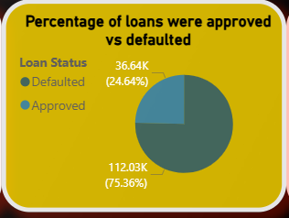
- A notable portion is defaulted, indicating credit risk

🔹 Interpretation
📌 Observation
The pie chart shows that approved loans constitute the majority, while defaulted loans form a smaller but significant portion of the total loan portfolio. This indicates that the lending institution maintains a relatively strong approval success rate.
📈 Insight
Although approvals dominate, the presence of defaults highlights the need for improved risk mitigation strategies to further reduce financial losses.
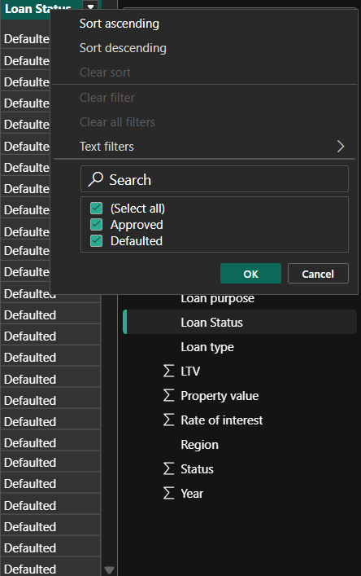

Bar Chart – Region with Highest Loan Defaults (Detailed)
🔹 Purpose of This Visual
This bar chart identifies which geographical region has the highest number of loan defaults.
It helps financial institutions understand regional risk patterns and take preventive actions.

This bar chart highlights regional loan default distribution, allowing banks to identify high-risk regions and implement targeted risk management strategies

Image has been shown for the help

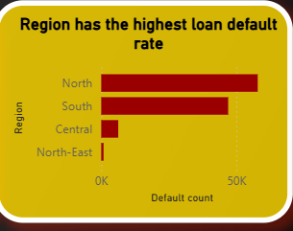
Approved Loan Count =
CALCULATE(
COUNT('LoanData'[Loan_ID]),
'LoanData'[Loan Status] = "Approved"
)

The Approved Loan Count DAX measure is used to calculate the total number of loans that have been approved in the dataset. It works by using the CALCULATE function, which changes the filter context of the data before performing a calculation. Inside the function, COUNT('LoanData'[Loan_ID]) counts the number of loan records, assuming each Loan_ID represents a unique loan application. The filter condition 'LoanData'[Loan Status] = "Approved" ensures that only those records where the loan status is marked as approved are included in the calculation. As a result, this measure dynamically returns the number of approved loans based on any applied filters such as region, loan purpose, or gender, making it highly useful for analyzing approval trends across different segments in Power BI dashboards.

Stacked bar chart for Approved vs Disapproved loans,

We use a stacked bar chart because it allows us to compare total loan volume across categories while simultaneously showing the proportion of approved and disapproved loans within each category. Unlike a simple bar chart, a stacked bar provides both overall comparison and composition analysis in a single visual. This makes it especially useful for understanding how approval and disapproval outcomes vary across different regions, loan purposes, or customer segments.
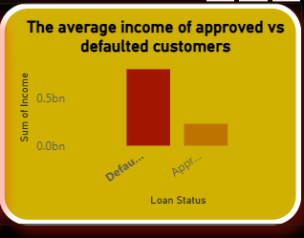
Interpretation:
The stacked bar chart shows that while the total number of loan applications may be high in certain categories, the approval and disapproval portions differ significantly. Categories with a larger approved segment indicate stronger creditworthiness and lower risk, whereas categories with a higher disapproved segment reflect stricter lending decisions or higher applicant risk. This visualization helps financial institutions identify segments where approval rates are low and refine credit policies to improve decision-making and risk management.

Overall Detailed Observation – Loan Default Prediction Dashboard Project
The Loan Default Prediction Dashboard provides a comprehensive and data-driven view of loan approval and default behavior by analyzing multiple critical factors such as loan purpose, credit score, income level, region, gender, and loan status. The project effectively combines interactive visuals and DAX calculations to transform raw loan data into meaningful insights that support better financial decision-making.
From the treemap analysis, it is observed that loan defaults are concentrated in specific loan purposes rather than being evenly distributed. This highlights that certain types of loans inherently carry higher risk and therefore require stricter credit assessment and monitoring. The scatter plot further reinforces the importance of credit score by showing a clear positive relationship between higher credit scores and increased loan approvals, confirming that credit history is a key determinant in lending decisions.
The stacked bar chart comparing approved and disapproved loans reveals noticeable variation across different categories such as regions or loan purposes. Some segments demonstrate a strong approval ratio, indicating stable borrower profiles, while others show higher disapproval proportions, reflecting elevated risk or stricter lending criteria. The regional bar chart complements this insight by identifying geographical areas with higher default occurrences, suggesting that economic and demographic conditions significantly influence repayment behavior.
The pie chart provides a high-level summary of overall loan performance, showing that approved loans form the majority of the portfolio, while defaulted loans still represent a significant portion that cannot be ignored. This balance indicates a generally healthy lending system but also emphasizes the need for improved risk mitigation strategies. Additionally, the column chart comparing average income clearly shows that approved borrowers tend to have higher income levels than defaulted borrowers, validating income as a crucial factor in repayment capacity.
The inclusion of interactive slicers enhances the dashboard’s usability by allowing users to dynamically filter data and observe how loan behavior changes across different demographics and categories. Overall, the project successfully demonstrates how Power BI, DAX measures, and data visualization can be used together to identify risk patterns, improve credit decision-making, and support strategic planning in financial institutions. This dashboard is not only analytically strong but also practical, scalable, and suitable for real-world banking and finance applications.

